**To:** National University of Computer and Emerging Sciences  
**From:** Waleed Malik and Umamah Hussain

**Date:** 11th October, 2023

**Subject:** Assessing Academic Pressure Among Students At FAST University  
  
**Introduction summary:**

Academic stress is a prevalent issue affecting university students worldwide, with far-reaching implications for their overall well-being and academic success. This report aims to provide a comprehensive analysis of academic stress based on survey data conducted at FAST NU and relevant external sources.

This report outlines the pervasive and damaging effects of academic pressure, including the constant academic pressure faced by students, a deterioration in mental well-being, reduction in leisure time necessary for pursuing personal interests, a decline in social engagements, challenges in achieving a harmonious balance between personal life and academic commitments, and academic support services.

**Academic Pressure:**

Institutions should prioritize the delivery of high-quality education while considering how much academic pressure students can handle. The efficacy of education is contingent upon students' ability to derive benefits without being overwhelmed.

According to the conducted survey, it has been found that:

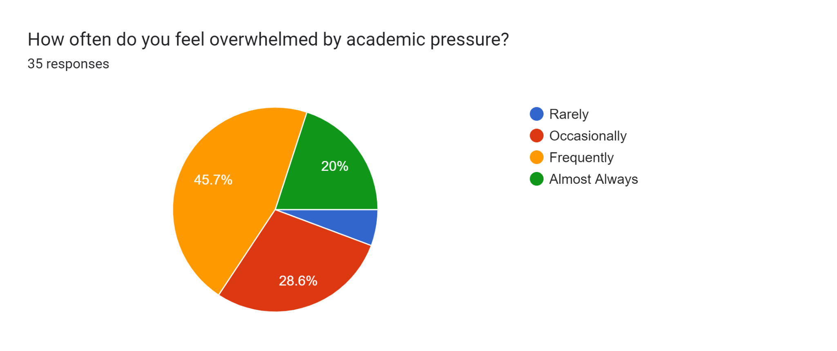

Within the surveyed group of 35 students, 7 out of 35 consistently reported experiencing a sense of being overwhelmed. Additionally, 16 out of 35 students frequently expressed feeling overwhelmed, while 10 out of 35 students reported occasional episodes of experiencing such pressure. Merely 2 out of 35 students indicated rare occurrences of being overwhelmed.

Forms response chart. Question title: On a scale of 1 to 5, how would you rate the overall level of academic pressure you feel?
. Number of responses: 35 responses.

The bar chart unequivocally illustrates the persistent burden on students. Out of all the respondents, 17.1% indicated experiencing low pressure, 11.4% mentioned a sense of moderate pressure, 45.7% conveyed enduring high pressure, and 25.7% acknowledged enduring very high levels of pressure.

In a number of studies, authors found that the most frequently reported factors contributing to stress and anxiety around the examination periods were extensive course loads, lack of physical exercise, and long duration of exams, reported by the students (Harikiran, 2021). When academic requirements escalate beyond manageable levels, the educational pursuit transforms from a conducive learning and growth-oriented venture to an obligatory exertion. In such circumstances, both the student and the institution are deprived of potential benefits.

Hence, it is imperative to cultivate an academic environment that fosters an enjoyable and intellectually stimulating learning experience, maintaining a balance that is challenging yet manageable.

**Mental Well-being:**

Ensuring the mental well-being of university students is paramount, especially in the face of academic stress. The demanding nature of education at Fast university has significantly impacted students' mental health, subsequently influencing both their overall quality of life and academic performance.  
  
Forms response chart. Question title: To what extent has academic pressure affected your mental and physical well-being?
. Number of responses: 35 responses.

The bar chart clearly illustrates the substantial impact of academic pressure on students. Approximately 80% of the respondents indicated experiencing adverse effects on both their mental and physical well-being.

Results from literature suggest higher level of stress to be associated with poor academic performance (Sohail, 2022). Addressing the mental and physical well-being of students amidst challenging academics is crucial for fostering a positive and nurturing learning environment. Implementing mental health support systems, stress management programs, counseling services, and promoting a healthy work-life balance are vital steps Fast university can take to mitigate the adverse effects of academic stress on mental health.

**Leisure time:**

Leisure time holds immense value in the lives of university students, providing crucial moments for relaxation, personal development, and self-expression. Regrettably, the prevalent academic pressures often encroach upon this precious free time, limiting students' chances to pursue personal hobbies and engage in leisure activities that can significantly enhance their overall well-being.

This is also reflected in the results from the survey:  
  
Forms response chart. Question title: How has the current course load affected the amount of free time you have for leisure activities and personal interests?
. Number of responses: 35 responses.

Ensuring that students have ample leisure time is essential for their holistic development and overall academic success. Striking a balance between academic responsibilities and leisure pursuits is crucial to promote a well-rounded educational experience that nurtures both the mind and the soul.

**Social Engagements:**  
  
The university experience isn't solely about academic endeavors; it encompasses the vibrant tapestry of social interactions, the cultivation of friendships, and the forging of enduring relationships. However, the weight of academic pressure can significantly impact students' ability to actively participate in social engagements and form meaningful connections with their peers.

To gain a better understanding of this dynamic, we also focused on the experiences and perspectives of students in this regard.  
  
Forms response chart. Question title: How has academic pressure affected your social life and relationships?
. Number of responses: 35 responses.

The survey results revealed that 80% of the respondents experienced a decline in their social engagements.

Fast University should focus on including more events, trips, and seminars within the university curriculum as it plays a pivotal role in promoting social interactions and fostering a vibrant campus culture. Balancing academic excellence with a rich social environment ensures that students not only excel in their studies but also grow personally through meaningful connections and diverse experiences.

**Balance between personal life and academic commitments:**

Striking an equilibrium between personal life and academic responsibilities proves to be a demanding task for university students. The demanding academic landscape, consisting of lectures, assignments, and examinations, frequently infringes upon the personal domains essential for self-care, familial engagement, and involvement in extracurricular activities.

The survey results regarding this are as follows:

Forms response chart. Question title: How do you manage to balance academic responsibilities with personal and extracurricular activities?
. Number of responses: 35 responses.

It can very well be seen that a majority (68.6%) of respondents are either unable to maintain a proper balance between academics and personal life or they are sacrificing their personal time to complete academic assignments.

Finding a suitable equilibrium that allows students to excel academically while also nurturing their personal lives is essential. University needs to support students in managing their academic workload effectively, enabling them to allocate time for self-care, family interactions, and meaningful engagement in extracurricular pursuits.

**Academic Support Services:**

The provision of Academic Support Services is vital for any university. The lack of such services at Fast University, an already academically demanding institution, has exacerbated the challenges students face. In the absence of consistent guidance and support, navigating through strenuous semesters becomes arduous. This inadequacy often leads to students feeling overwhelmed and fatigued due to the relentless academic pressure.

Forms response chart. Question title: Do you think the university itself offers proper academic support services? (e.g., academic advising, tutoring and assistance)
. Number of responses: 34 responses.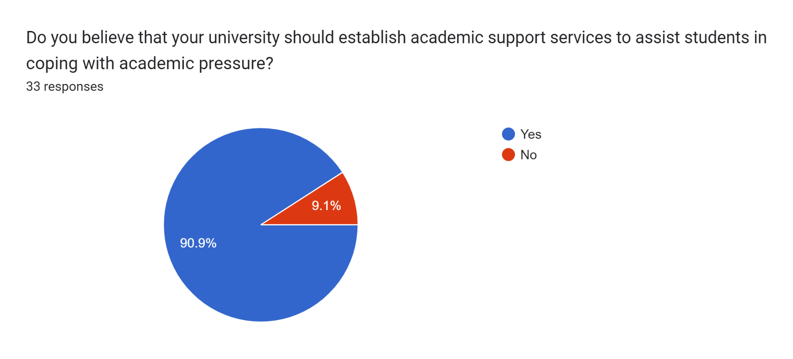

1. **Addressing Individual Academic Needs:**

These support services cater to the individual academic needs of students, providing tailored assistance based on their strengths, weaknesses, and learning styles. Without such personalized guidance, students might find it challenging to optimize their academic potential.

1. **Academic Advising:**

Professional guidance for academic and career planning, course selection, and degree progression to ensure students stay on track with their academic goals.

1. **Library and Research Support:**

Assistance in utilizing library resources, accessing online databases, and conducting effective research for academic projects and assignments.

1. **Peer Tutoring/Mentorship Programs:**

Pairing students with experienced peers who can provide academic support, tutoring, and mentorship in specific subjects or study techniques.

1. **Career Services:**

Guidance on career planning, job searches, resume/CV building, interview preparation, and internship opportunities to prepare students for the professional world.

1. **Online Learning Resources:**

Access to online courses, digital libraries, interactive learning materials, and virtual study groups to complement traditional classroom learning.

1. **Financial Aid and Scholarships Assistance:**

Guidance on applying for financial aid, scholarships, grants, and loans to ease the financial burden associated with education.

1. **Feedback and Consultation Sessions:**

Regular sessions with faculty or advisors for academic progress evaluation, feedback on performance, and guidance for improvement.

1. **Health and Wellness Centers:**

Access to healthcare professionals, counseling, and wellness programs to address both physical and mental health concerns impacting academic performance. According to (Alborzkouh, 2021) teaching stress management methods has been shown to be an effective strategy for assisting students dealing with high levels of stress and pressure.

Providing a comprehensive array of academic support services ensures that students receive the necessary guidance, resources, and assistance to succeed academically while maintaining their well-being throughout their university journey.

**Conclusion:**  
  
In conclusion, the survey data highlights the pervasive issue of academic stress among university students at FAST-NU. The effects of academic pressure are far-reaching and impact students' overall well-being, leisure time, social lives, and personal relationships. It is imperative for the university to address this issue comprehensively and provide the necessary support services to help students navigate academic pressure effectively. By implementing the suggested improvements, Fast university can create a more favorable and supportive academic environment for their students.

# Bibliography

Alborzkouh, P. N. (2021). *A review of the effectiveness of stress management skills training on academic vitality and psychological well-being of college students.*

Harikiran, A. S. (2021). *Perceived sources of stress amongst final year dental undergraduate students.* Bangalore: Indian Journal of Dental Research.

Sohail, N. (2022). *Stress and academic performance among medical students.* J Coll Physicians Surg Pak.